# Homework: Trees and Tree-Like Data Structures

This document defines the **homework assignments** for the ["Data Structures" course @ Software University](https://softuni.bg/trainings/1147/Data-Structures-June-2015). Please submit a single zip / rar / 7z archive holding the solutions (source code) of all below described problems.

## Play with Trees

You are given a **tree of N nodes** represented as a set of N-1 pairs of nodes (parent node, child node).

Write a program to read the tree from the console and find:

* The **root** node
* All **leaf** nodes (in increasing order)
* All **middle** nodes (in increasing order)
* * The **longest path** in the tree (the leftmost if several paths have the same longest length)
* * All paths in the tree with **given sum** P of their nodes (from the leftmost to the rightmost)
* ** All **subtrees with given sum** S of their nodes (from the leftmost to the rightmost)

|  |  |  |  |
| --- | --- | --- | --- |
| **Input** | **Comments** | **Tree** | **Output** |
| 9  7 19  7 21  7 14  19 1  19 12  19 31  14 23  14 6  27  43 | N = 9  Nodes: 7🡪19, 7🡪21, 7🡪14, 19🡪1, 19🡪12, 19🡪31, 14🡪23, 14🡪6  P = 27  S = 43 |  | Root node: 7  Leaf nodes: 1, 6, 12, 21, 23, 31  Middle nodes: 14, 19  Longest path: 7 -> 19 -> 1 (length = 3)  Paths of sum 27: 7 -> 19 -> 1 7 -> 14 -> 6  Subtrees of sum 43: 14 + 23 + 6 |

Hints:

* Use the recursive Tree<T> definition. Keep the **value**, **parent** and **children** for each tree node:

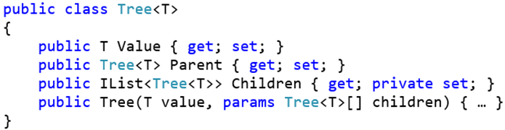

* Modify the Tree<T> **constructor** to **assign a parent** for each child node:

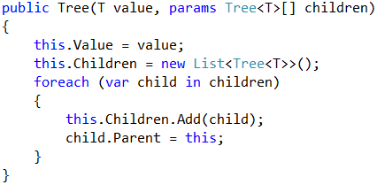

* Use a **dictionary** to map nodes by their value. This will allow you to find the tree nodes during the tree construction (when you read the input data, you get the node values):



* Write a method to **find the tree node by its value or create a new node** if it does not exist:

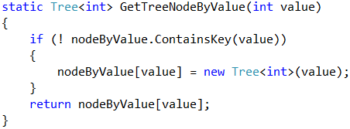

* Now you are ready to **read the input data**. You are given the **tree edges** (parent + child). Use the dictionary to lookup the parent and child nodes by their values:

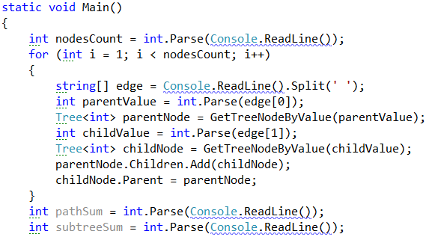

* Find the **root** node:

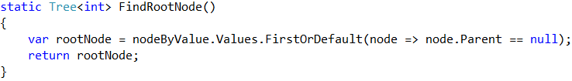

* Find all **middle** nodes:

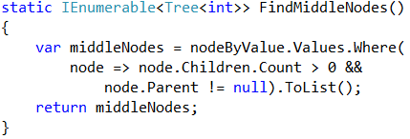

## Traverse and Save Directory Contents in a Tree

Define two classes to keep files and folders:

* File { string name, int size }
* Folder { string name, File[] files, Folder[] childFolders }

Write a program to **build a tree keeping all files and folders** from the hard drive starting from **C:\WINDOWS**. You may use the .NET directory listing APIs: [DirectoryInfo.GetFiles()](https://msdn.microsoft.com/en-us/library/system.io.directoryinfo.getfiles(v=vs.110).aspx) and [DirectoryInfo.GetDirectories()](https://msdn.microsoft.com/en-us/library/s7xk2b58(v=vs.110).aspx).

Implement a method that calculates the **sum of the file sizes** **in given subtree** of the tree and test it accordingly. **Use recursive tree traversal**.

## *** Calculate Arithmetic Expression

Write a program to **calculate the value of given arithmetic expression**. Take into account that arithmetic operations have different priorities. Consider also processing brackets correctly. Handle the unary minus as well. Examples:

|  |  |
| --- | --- |
| **Input** | **Output** |
| 5 + 6 | 11 |
| (2 + 3) * 4.5 | 22.5 |
| 2 + 3 * 1.5 - 1 | 5.5 |
| -2 - -1 | 3 |
| 3 ++ 4 | error |
| 1.5 – 2.5 * 2 * (-3) | 16.5 |
| 1/2 | 0.5 |

Hint: consider implementing the ["Shunting Yard" algorithm](https://en.wikipedia.org/wiki/Shunting-yard_algorithm).